**Lab 2**

**Theory**

Cascading Style Sheets, commonly known as CSS, is a style sheet language used to enhance the appearance of a document written in HTML or XML. It provides a powerful control over the presentation of an HTML document, allowing developers and designers to define how elements are positioned in the browser. CSS describes how HTML elements should be displayed on screen, paper, or other media. It can control the layout of multiple web pages all at once, saving a lot of work. With CSS, you can change the look of an entire website by changing just one file3. It’s easy to learn and understand, but it provides a wide array of attributes, making it possible to give a far better look to your HTML page in comparison to HTML attributes.

**Task 1:**

**Using HTML and CSS design the following layout.**

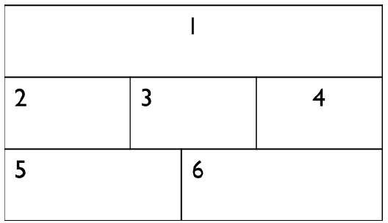

**HTML**

<!DOCTYPE html>

<html lang="en">

<head>

<meta charset="UTF-8">

<meta name="viewport" content="width=device-width, initial-scale=1.0">

<title>Layout Design</title>

<link rel="stylesheet" href="1_style1.css">

</head>

<body>

<div class="row1">

<h4>1</h4>

</div>

<div class="row2">

<div class="container2">

<h4>2</h4>

</div>

<div class="container3">

<h4>3</h4>

</div>

<div class="container4">

<h4>4</h4>

</div>

</div>

<div class="row3">

<div class="container5">

<h4>5</h4>

</div>

<div class="container6">

<h4>6</h4>

</div>

</div>

</body>

</html>

**CSS**

.row1{

background-color: #bdeab5;

padding: 10px 0px;

margin: 0.1%;

text-align: center;

}

.row2::after{

content: " ";

display: table;

clear: both;

}

.container2, .container3, .container4{

float: left;

width: 33.13%;

background-color: #bdeab5;

margin: 0.1%;

text-align: center;

padding: 10px 0px;

}

.row3::after{

content: " ";

display: table;

clear: both;

}

.container5, .container6{

float: left;

width: 49.8%;

background-color: #bdeab5;

margin: 0.1%;

text-align: center;

padding: 10px 0px;

}

**Output**

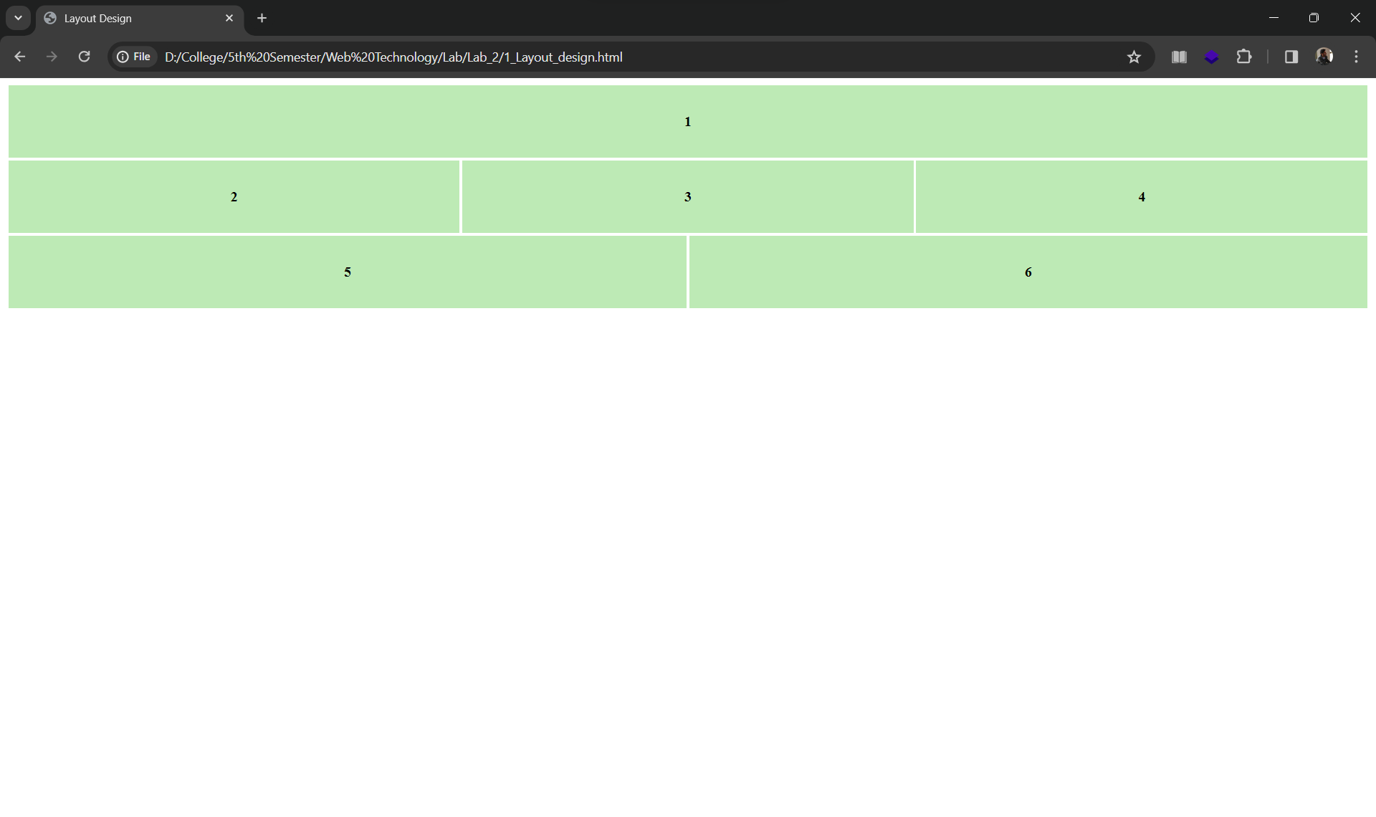

**Task 2:**

**Design your class routine using CSS.**

**HTML**

<!DOCTYPE html>

<html lang="en">

<head>

<meta charset="UTF-8">

<meta name="viewport" content="width=device-width, initial-scale=1.0">

<title>Class Routine</title>

<link rel="stylesheet" href="2_style2.css">

</head>

<body>

<h2>Class Routine of BSc. CSIT 5<sup>th</sup> Semester 2023</h2>

<table class="routine">

<tr>

<th>Day/ Time</th>

<th> 7:00 - 9:00</th>

<th> 9:00 - 9:30</th>

<th> 9:30 - 11:30</th>

<th> 11:30 - 1:30</th>

</tr>

<tr>

<td class="day"> Sunday</td>

<td>IP (SS2)</td>

<td>BREAK</td>

<td>SM (SS1)</td>

<td>DAA (TNY)</td>

</tr>

<tr>

<td class="day"> Monday</td>

<td>EPC (IC)</td>

<td colspan="3">Field Work</td>

</tr>

<tr>

<td class="day"> Tuesday</td>

<td>IP (SS2)</td>

<td>BREAK</td>

<td>SM (SS1)</td>

<td></td>

</tr>

<tr>

<td class="day"> Wedensday</td>

<td>Crypto (RDB)</td>

<td>BREAK</td>

<td>WT (TK)</td>

<td>SAD (MB)</td>

</tr>

<tr>

<td class="day"> Thursday</td>

<td>DAA (TNY)</td>

<td colspan="3">Presentation</td>

</tr>

<tr>

<td class="day"> Friday</td>

<td>Crypto (RDB)</td>

<td>BREAK</td>

<td>WT (TK)</td>

<td>SAD (MB)</td>

</tr>

</table>

</body>

</html>

**CSS**

.routine{

border-collapse: collapse ;

width: 500px;

}

.routine td, th{

border: 1px solid black;

padding: 5px;

}

.routine th{

background-color: aqua;

}

.day{

font-weight: bold;

}

**Output**

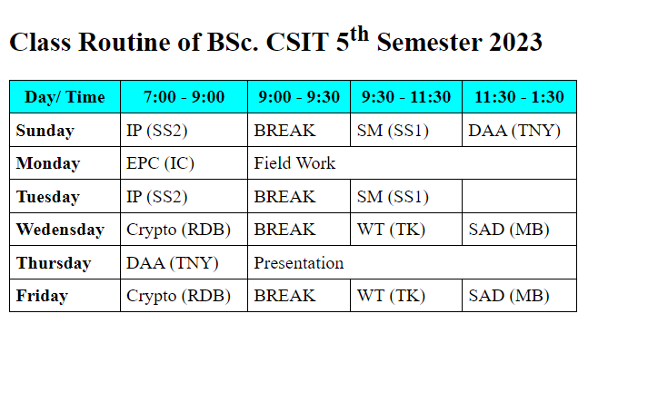

**Task 3:**

**Write a code for the position relative, absolute, fixed and make HTML page using CSS position.**

**HTML**

<!DOCTYPE html>

<html lang="en">

<head>

<meta charset="UTF-8" />

<meta name="viewport" content="width=device-width, initial-scale=1.0" />

<title>Positioning Example</title>

<link rel="stylesheet" href="3_style3.css">

</head>

<body>

<header>

<h1>Header - Fixed Position</h1>

</header>

<section>

<div class="relative-box">

<h2>Relative Positioning</h2>

<p>This box is positioned relative to its normal position.</p>

<div class="absolute-box">

<h3>Absolute Positioning</h3>

<p>This box is positioned absolutely inside the relative box.</p>

</div>

</div>

<div class="fixed-box">

<h2>Fixed Positioning</h2>

<p>

This box is fixed to the viewport and stays in the same position when

scrolling.

</p>

</div>

</section>

<footer>

<p>Footer - Fixed Position</p>

</footer>

</body>

</html>

**CSS**

body {

margin: 0;

padding: 0;

}

header {

background-color: #333;

color: #fff;

text-align: center;

padding: 10px;

position: fixed;

top: 0;

left: 0;

width: 100%;

z-index: 1000;

}

section {

margin-top: 60px;

padding: 20px;

}

.relative-box {

position: relative;

background-color: #f2f2f2;

padding: 10px;

margin: 10px;

}

.absolute-box {

position: absolute;

top: 50px;

left: 50px;

background-color: #b3e0ff;

padding: 10px;

}

.fixed-box {

position: fixed;

top: 100px;

right: 50px;

background-color: #ffc0cb;

padding: 10px;

}

footer {

background-color: #333;

color: #fff;

text-align: center;

padding: 10px;

position: fixed;

bottom: 0;

left: 0;

width: 100%;

}

**Output**

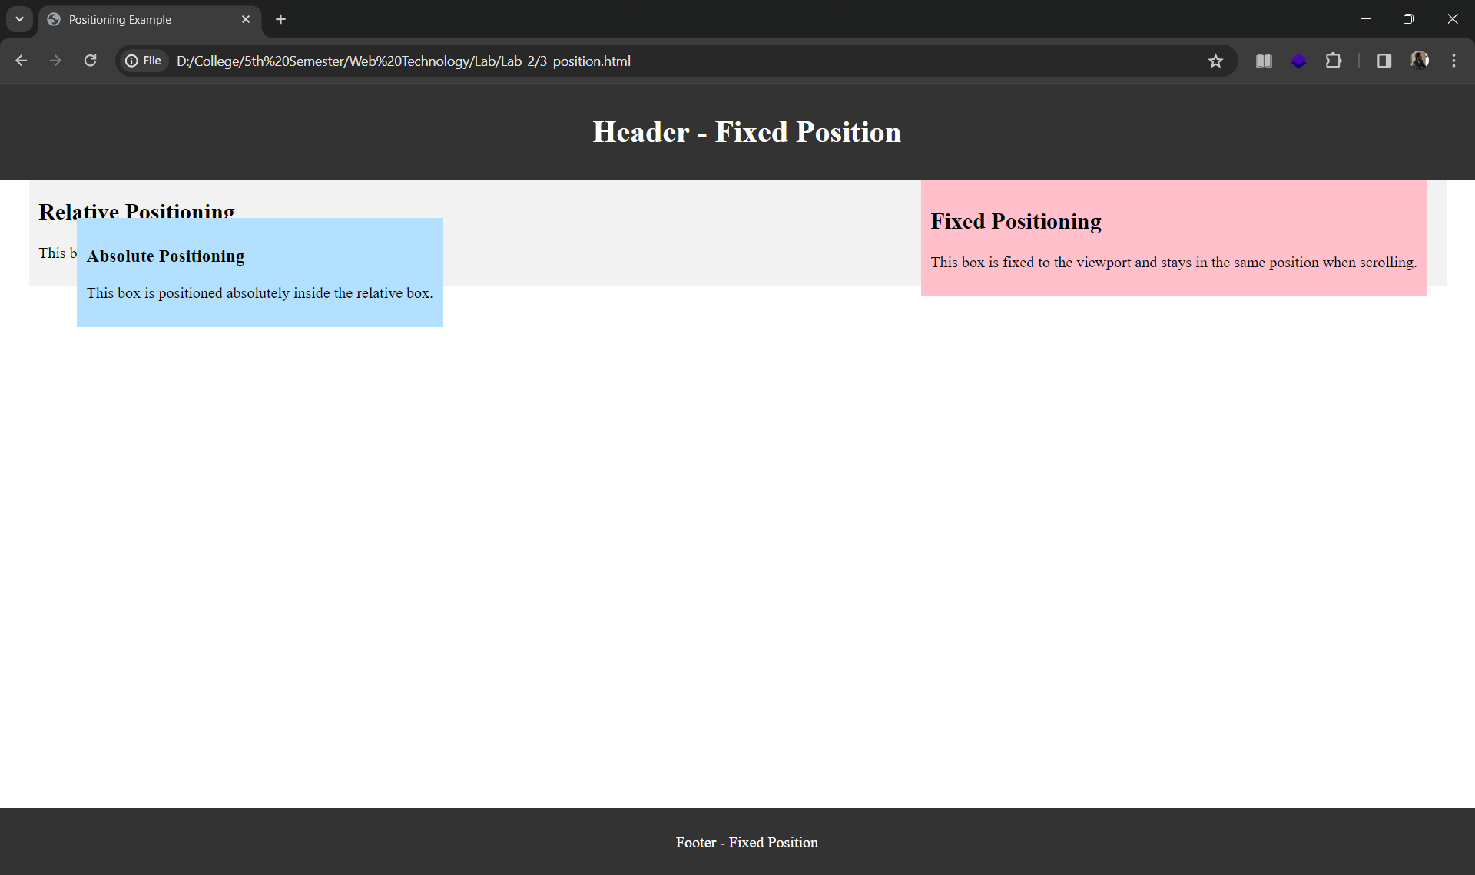

**Task4:**

**Using CSS design attractive 3D effect buttons.**

**HTML**

<!DOCTYPE html>

<html lang="en">

<head>

<meta charset="UTF-8" />

<meta name="viewport" content="width=device-width, initial-scale=1.0" />

<title>3D Effect Button</title>

<link rel="stylesheet" href="4_style4.css">

</head>

<body>

<button class="button">3D Effect Button</a>

</body>

</html>

**CSS**

body {

display: flex;

align-items: center;

justify-content: center;

height: 100vh;

margin: 0;

background-color: #f0f0f0;

}

.button {

padding: 12px 24px;

font-size: 16px;

text-align: center;

text-decoration: none;

cursor: pointer;

color: #fff;

background: linear-gradient(180deg, #4caf50 0%, #45a049 100%);

border: 1px solid #4caf50;

border-radius: 5px;

transition: transform 0.3s;

}

.button:hover {

transform: translateY(1px);

box-shadow: 0 6px 12px rgb(34, 169, 52);

}

.button:active {

transform: translateY(0);

}

**Output**

